CS 3303 Assignment Activity Unit 5

University of the People

CS 3303

Dr. Arya

18/7/2025

## 

## 

Efficiently managing urban traffic and emergency response is a critical challenge for modern cities. CityNet, a next-generation smart city network, leverages advanced data structures and algorithms to ensure that high-priority incidents are processed rapidly and resources are allocated optimally. This assignment explores how binary heaps and recursive algorithms can be used to solve CityNet’s real-world problems, such as dynamic traffic alert prioritization and route optimization for emergency services.

### **1. Binary Heaps for Real-Time Traffic Alert Management**

#### **a. Dynamic Prioritization with Binary Heaps**

CityNet receives an overwhelming volume of real-time traffic data, including both critical incidents and routine updates. A binary heap is an ideal structure for this scenario because it enables the system to efficiently retrieve and process the most urgent alerts first. In a heap, the highest (or lowest) priority element is always at the root, which allows for constant-time access and logarithmic-time insertion and deletion. For example, if an accident occurs, it can be assigned a higher priority than regular traffic flow data. As a result, CityNet ensures that emergencies such as accidents or severe congestion are addressed immediately, thereby reducing response times and minimizing the impact on urban mobility (Cutajar, 2018).

#### **b. Min-Heap vs. Max-Heap for Alert Prioritization**

The choice between a Min-Heap and a Max-Heap depends on the type of alerts CityNet is prioritizing. A **Max-Heap** places the highest priority alert (e.g., major accident, ambulance blockage) at the top, which is suitable when the most critical incidents must be processed first. Conversely, a **Min-Heap** places the lowest value at the top, which can be used to quickly remove routine or resolved alerts from the system. For prioritizing ambulance route blockages or severe incidents, a Max-Heap is more appropriate, whereas for managing less urgent data like routine traffic reports, a Min-Heap can help ensure that minor alerts do not clog the alert queue (A & R, 2023).

#### **c. Heap Operations for Real-Time Signal Optimization**

Binary heap operations such as insertion, deletion, and heapify are vital for the automation of traffic management tasks. When a new incident is detected, it is inserted into the heap according to its priority. Once an incident is resolved, it is removed (deleted) from the heap, and the heap is reorganized (heapified) to maintain its structure. CityNet can use these operations to automatically adjust traffic light signals based on the severity and location of incidents. For example, if a major accident is reported at an intersection, the heap ensures that the alert is processed immediately, triggering a signal change to reroute vehicles and minimize congestion in real time.

### **2. Recursive Algorithms for Dynamic Traffic Optimization**

#### **a. Recursion vs. Iteration in Congestion Management**

Recursive algorithms are particularly useful for breaking down complex problems, such as predicting and managing congestion patterns. Compared to iterative approaches, recursion can simplify the logic for tasks like traversing interconnected road networks or analyzing potential rerouting options. However, recursion may incur overhead due to repeated function calls and can be less efficient in scenarios where deep or repetitive computation is required. With the integration of memoization or dynamic programming, recursion can be optimized to efficiently manage real-time traffic rerouting, striking a balance between code simplicity and performance (Cutajar, 2018).

#### **b. Recursive Algorithm for Shortest Emergency Response Route**

Below is a simple recursive algorithm (based on Depth-First Search) to compute the shortest emergency response route while dynamically adjusting for blocked roads and congestion:

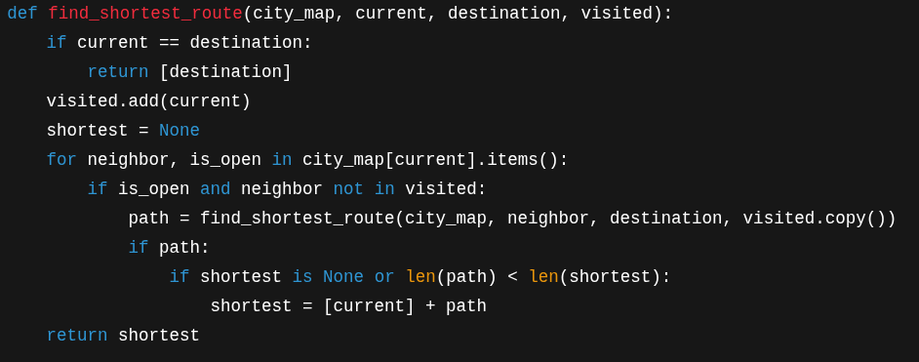

This algorithm explores all possible paths recursively, avoiding blocked or congested routes, and returns the shortest available route. By dynamically checking the road status, CityNet can quickly adapt to new incidents.

#### **c. Using Recursion to Simulate Future Traffic Conditions**

Recursion can also be employed to simulate and predict future traffic conditions by modeling the effect of current actions on future states. For example, a recursive function could analyze how changing a single traffic light affects traffic flow in subsequent time intervals across the network. By repeatedly applying the same function to future states, CityNet can proactively adjust signals and reroute vehicles before congestion occurs. This approach enables data-driven, anticipatory management of city traffic, improving both efficiency and safety (A & R, 2023).

By integrating binary heap operations and recursive algorithms, CityNet is able to effectively prioritize critical alerts and optimize emergency response routes in a dynamic urban environment. The use of these advanced data structures and algorithms not only streamlines real-time decision-making but also supports the system’s ability to predict and adapt to changing traffic patterns. As smart cities grow, these computational techniques are crucial for maintaining efficient and safe urban mobility.

# References

*A, A., & R, L. P. (2023). Advanced Data Structures and Algorithms: Learn How to Enhance Data Processing with More Complex and Advanced Data Structures (English Edition). BPB Publications.*

*Cutajar, J. (2018). Beginning Java Data Structures and Algorithms: Sharpen Your Problem-Solving Skills by Learning Core Computer Science Concepts in A Pain-Free Manner. Packt Publishing, Limited.*